FHA to FHA Refinance – Determining MIP Refund
A borrower is entitled to obtain an FHA MIP Refund when they are refinancing to another FHA Loan and currently have an FHA Loan. While the borrower will be charged the full MIP Fee on our new loan, they will get a paper credit on the Closing Statement for the MIP refund.
The amount of the refund will also be reflected on the FHA Case Number Assignment form. However, for the purpose of creating an estimate (prior to Origination) you will need to obtain the last Settlement Statement from the borrower.

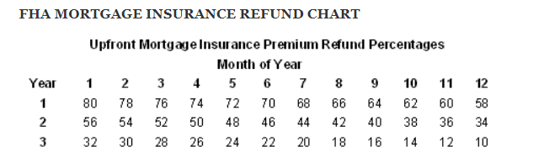

Example:
It has been 12 months since Steve bought using an FHA Loan. He will receive 58% refund of the original MIP fee reflected on their last Settlement Statement (HUD1).

